inp1_0.txt (n=25,C=94)

Iterative algorithm:

Total Cost: 1222

# of lines: 13

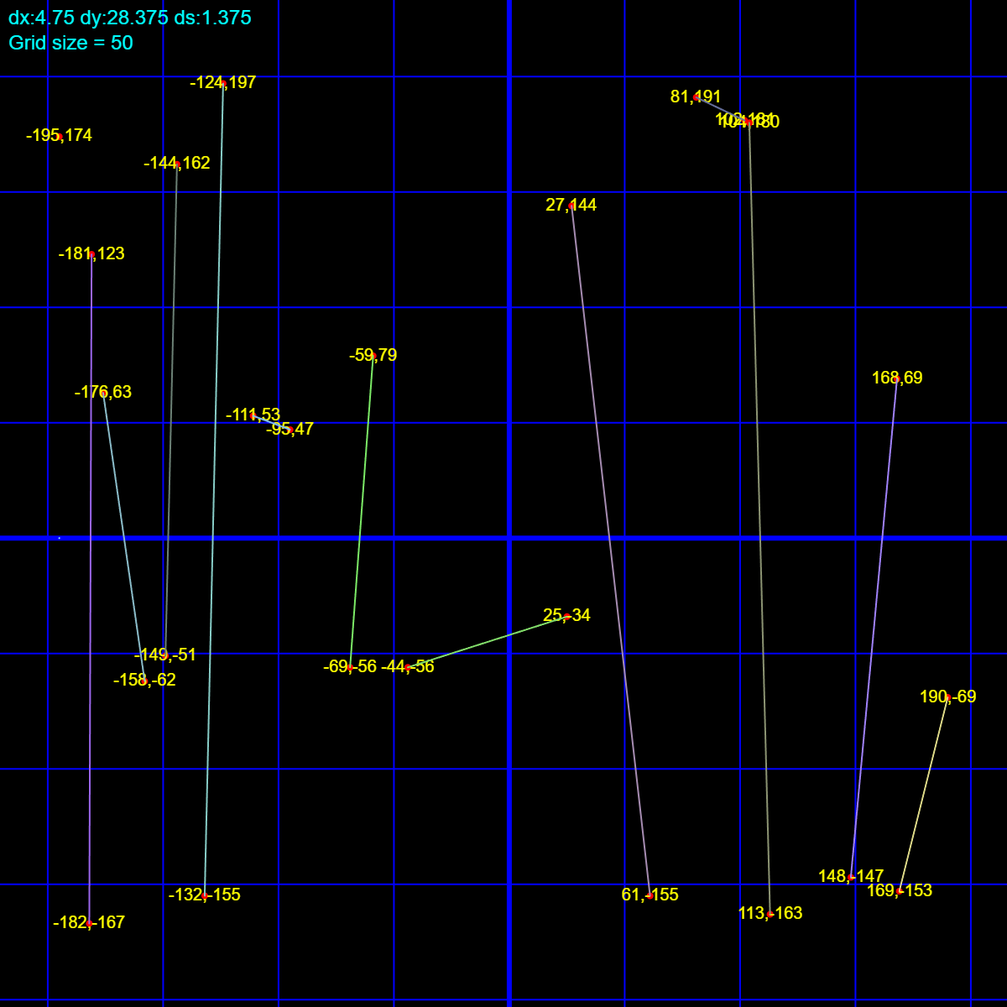

Time taken by the algorithm (in microseconds): 278

inp1_1.txt (n=25,C=94)

Recursive algorithm:

Total Cost: 1222

# of lines: 13

-

Time taken by the algorithm (in microseconds): 279

inp2_0.txt (n=50,C=3)

Iterative algorithm:

Total Cost: 75

# of lines: 25

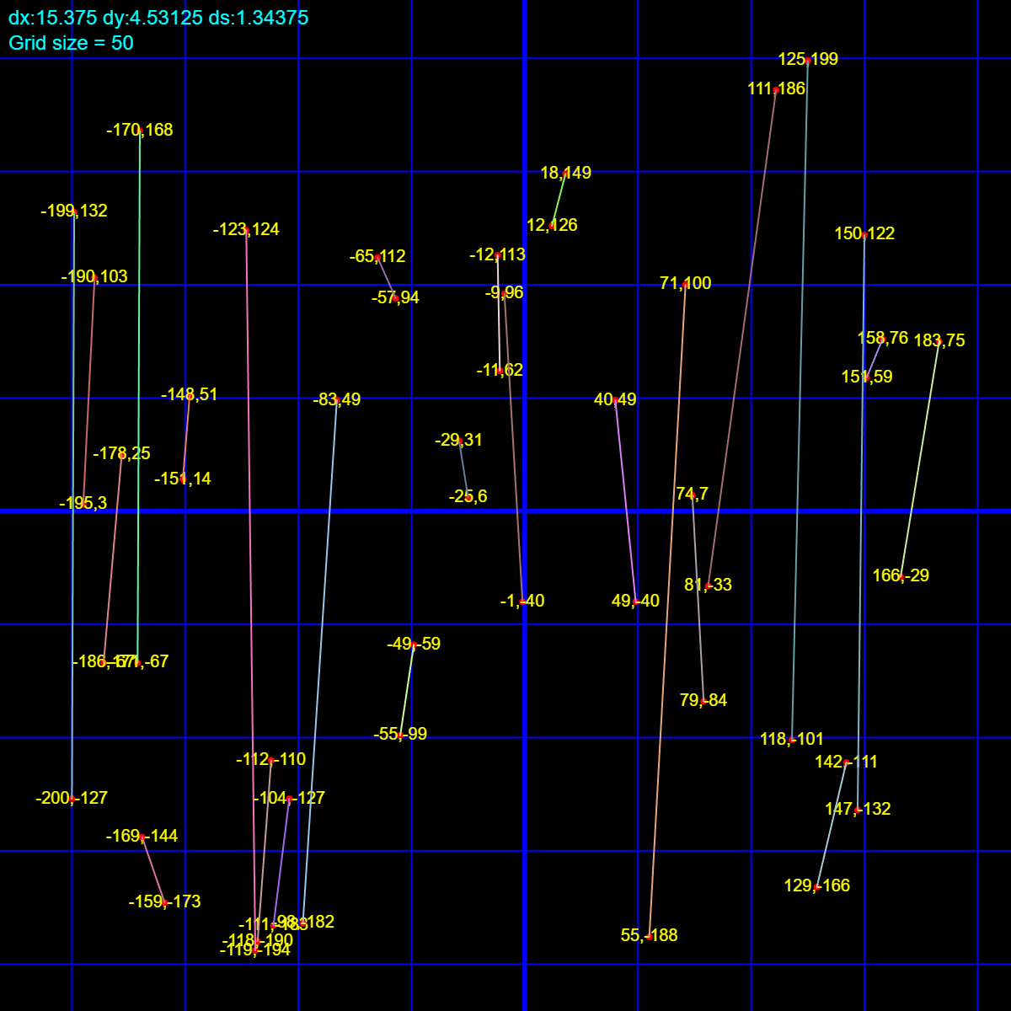

Time taken by the algorithm (in microseconds): 1124

inp2_1.txt (n=50,C=3)

Recursive algorithm:

Total Cost: 75

# of lines: 25

-

Time taken by the algorithm (in microseconds): 1148

inp3_0.txt (n=100,C=5)

Iterative algorithm:

Total Cost: 250

# of lines: 50

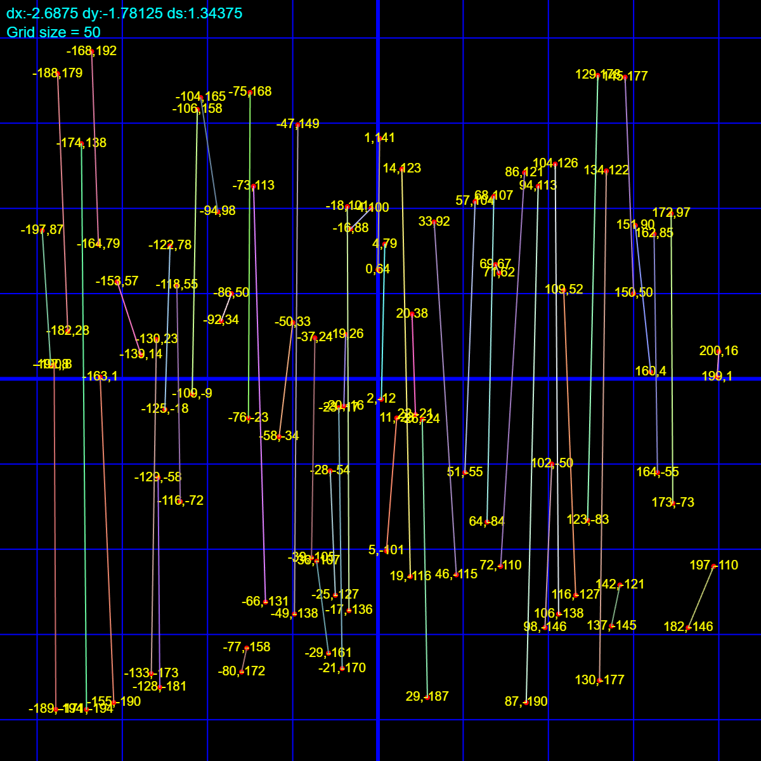

Time taken by the algorithm (in microseconds): 5918

inp3_1.txt (n=100,C=5)

Recursive algorithm:

Total Cost: 250

# of lines: 50

-

Time taken by the algorithm (in microseconds): 6058

inp4_0.txt (n=150,C=21)

Iterative algorithm:

Total Cost: 1575

# of lines: 75

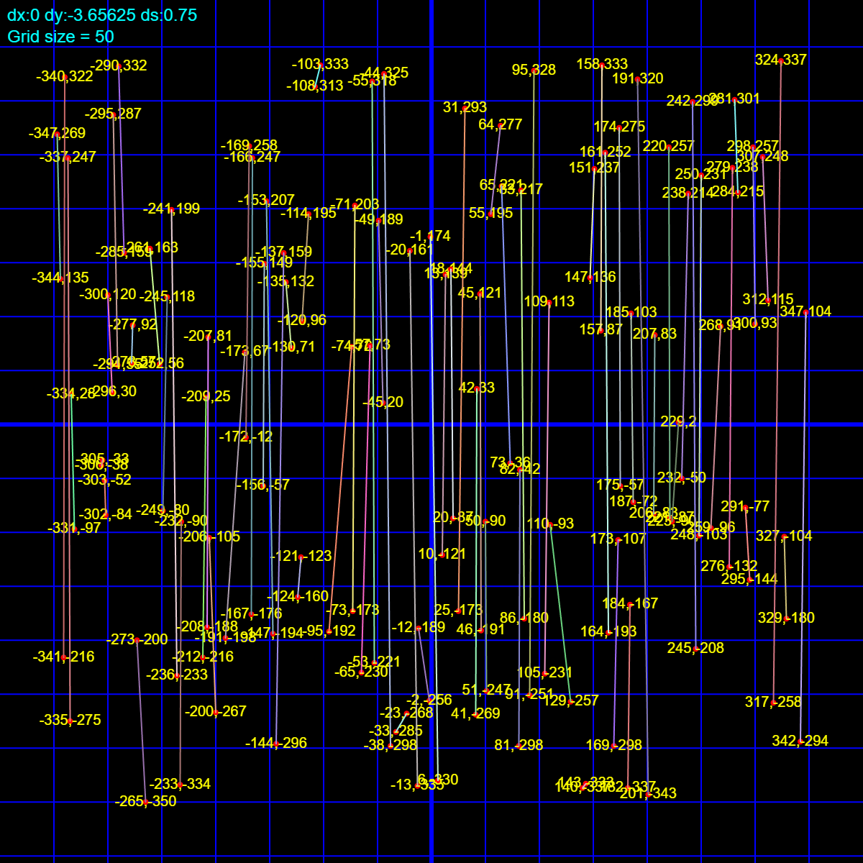

Time taken by the algorithm (in microseconds): 17657

inp4_1.txt (n=150,C=21)

Recursive algorithm:

Total Cost: 1575

# of lines: 75

-

Time taken by the algorithm (in microseconds): 18099

inp5_0.txt (n=200,C=72)

Iterative algorithm:

Total Cost: 7200

# of lines: 100

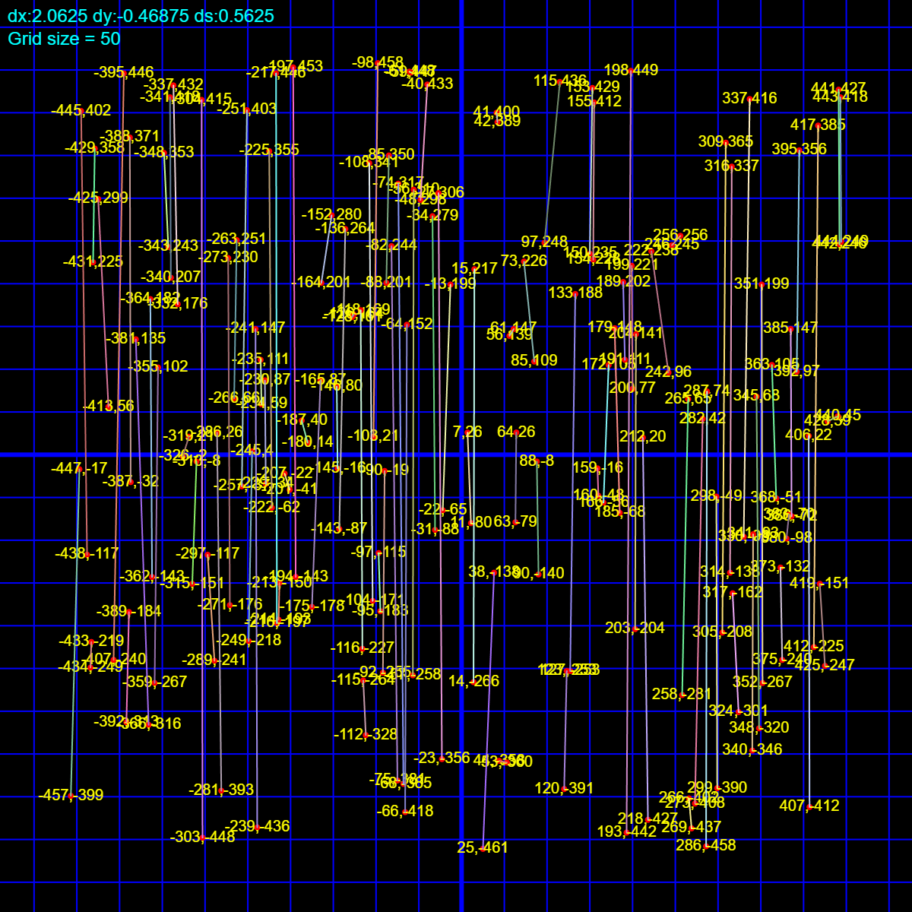

Time taken by the algorithm (in microseconds): 39616

inp5_1.txt (n=200,C=72)

Recursive algorithm:

Total Cost: 7200

# of lines: 100

-

Time taken by the algorithm (in microseconds): 40608

inp6_0.txt (n=475,C=38)

Iterative algorithm:

Total Cost: 9017.61

# of lines: 237

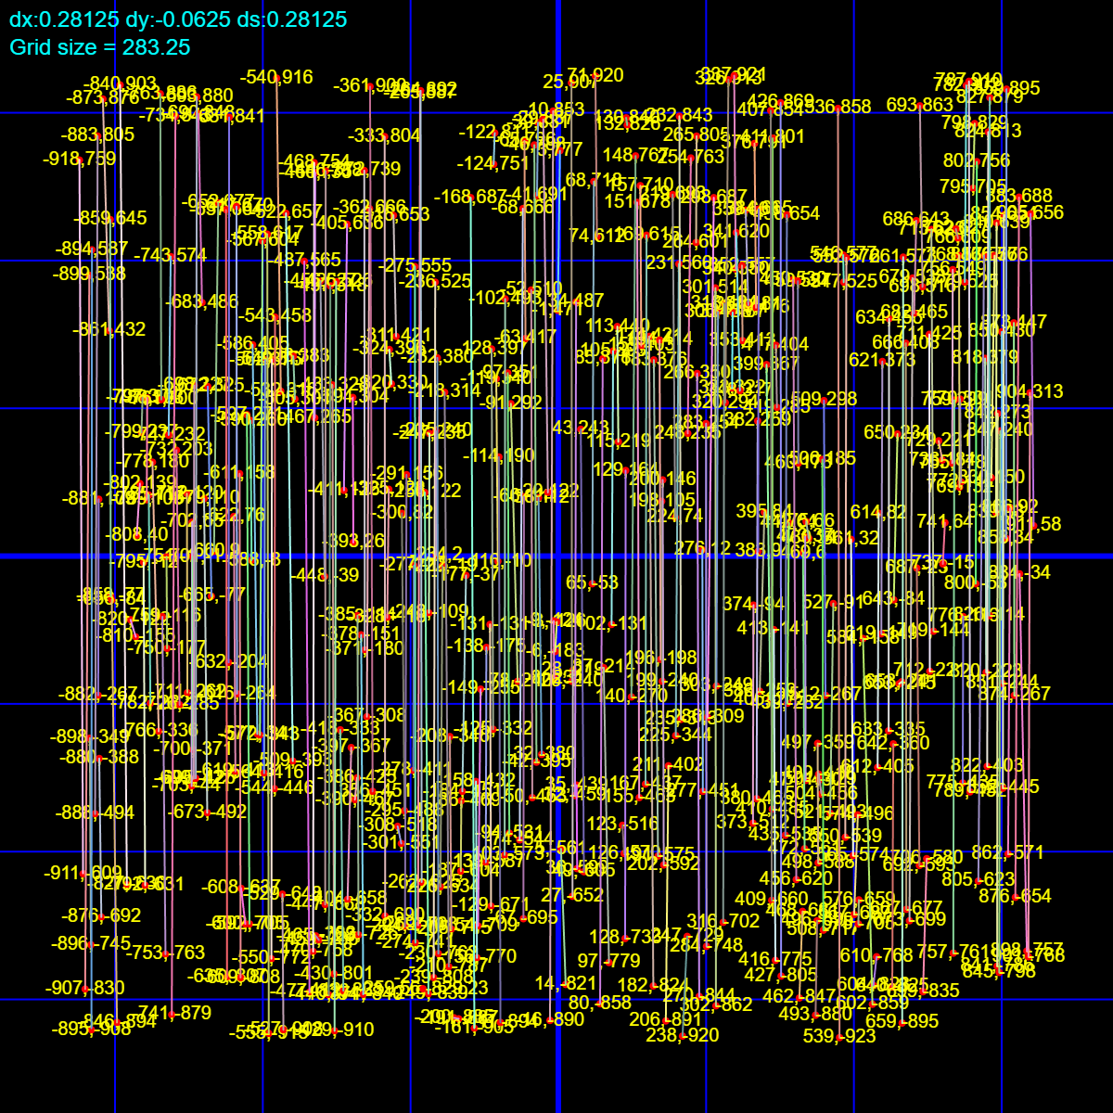

Time taken by the algorithm (in microseconds): 466737

inp6_1.txt (n=475,C=38)

Recursive algorithm:

Total Cost: 9017.61

# of lines: 237

-

Time taken by the algorithm (in microseconds): 463242

inp7_0.txt (n=100,C=5005)

Iterative algorithm:

Total Cost: 231531

# of lines: 44

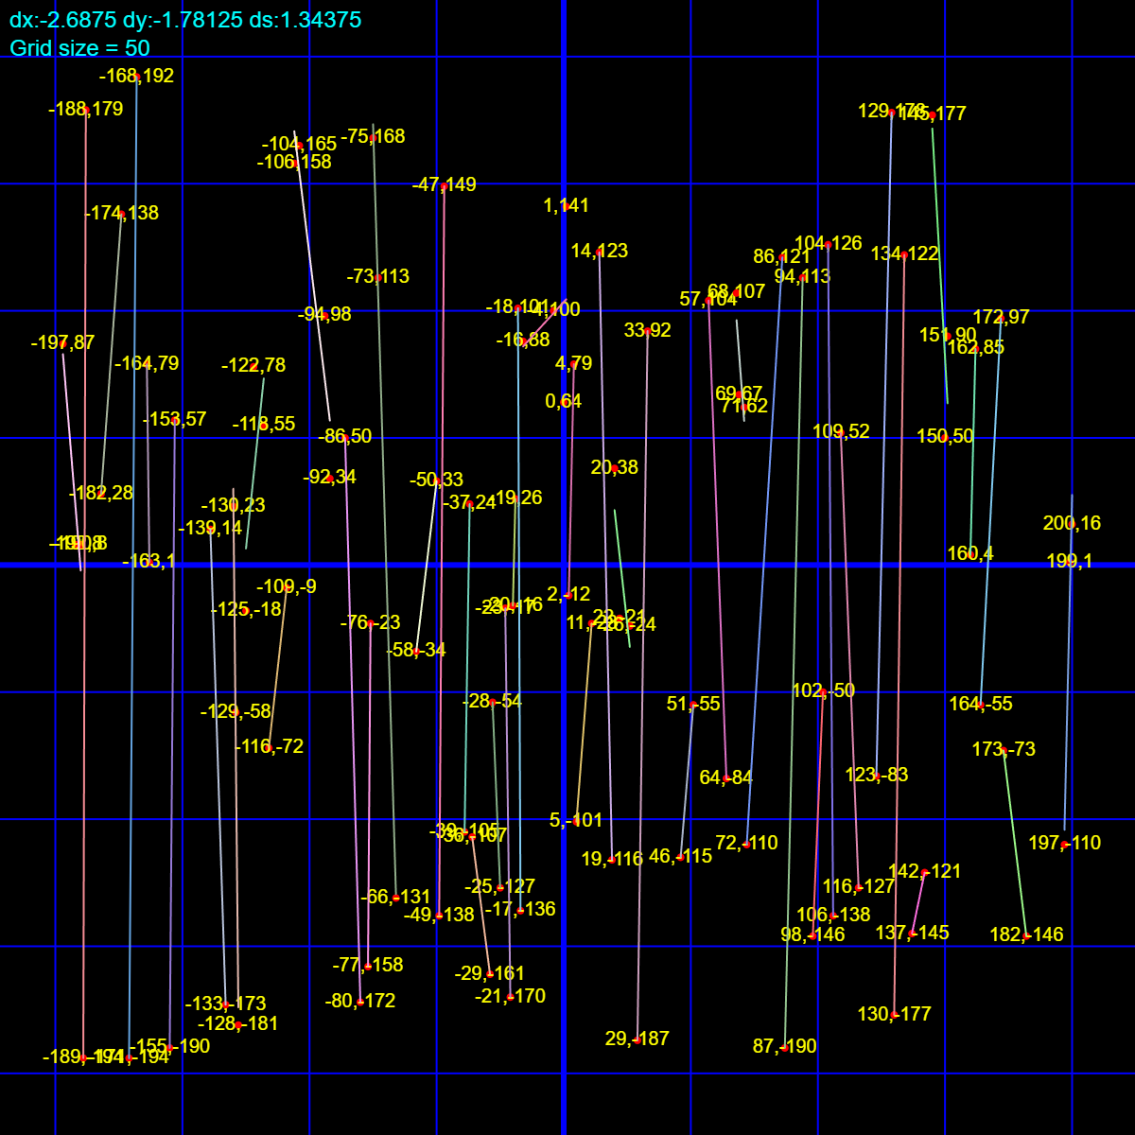

Time taken by the algorithm (in microseconds): 6021

inp7_1.txt (n=100,C=5005)

Recursive algorithm:

Total Cost: 231531

# of lines: 44

-

Time taken by the algorithm (in microseconds): 5689

inp8_0.txt (n=150,C=5021)

Iterative algorithm:

Total Cost: 355783

# of lines: 68

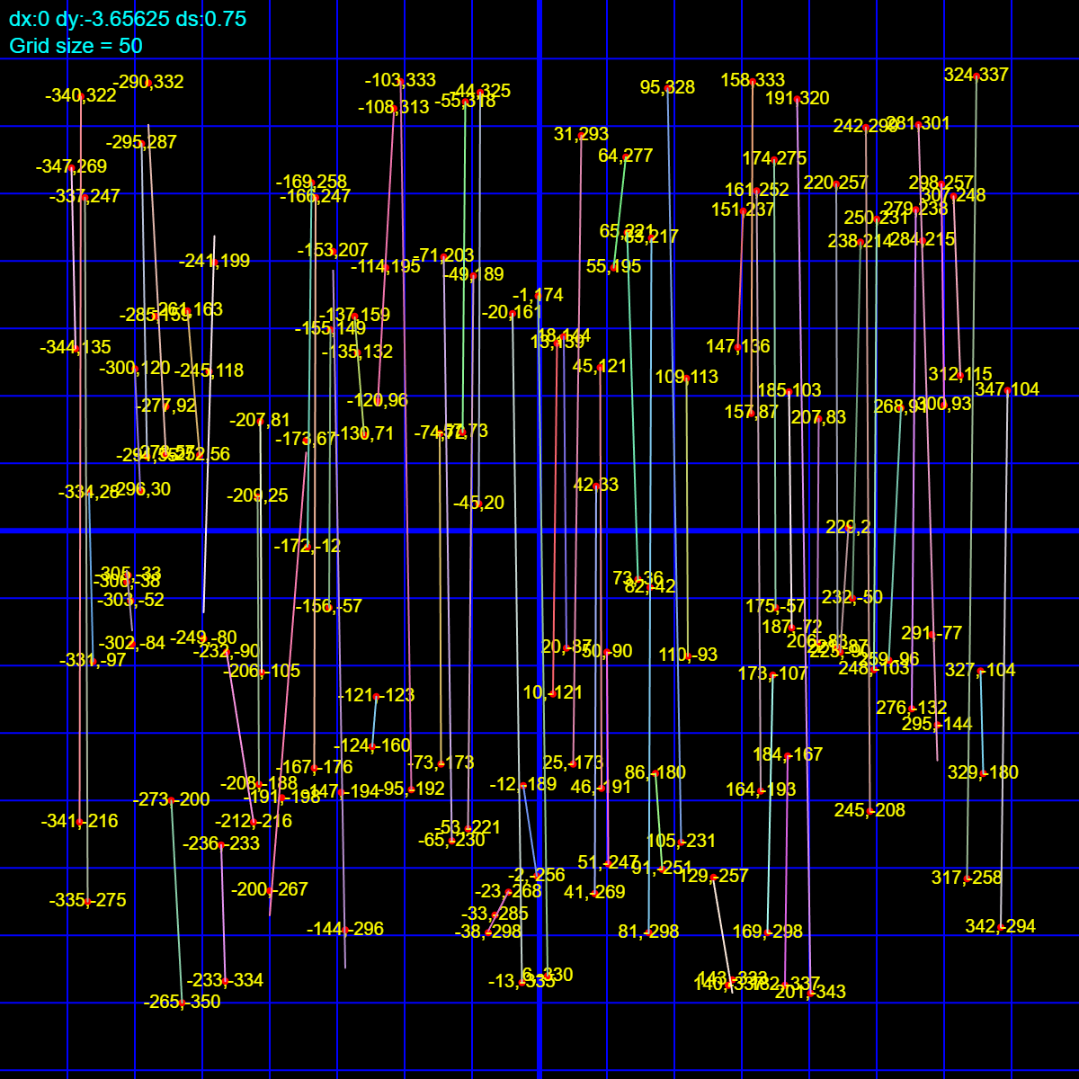

Time taken by the algorithm (in microseconds): 17761

inp8_1.txt (n=150,C=5021)

Recursive algorithm:

Total Cost: 355783

# of lines: 68

-

Time taken by the algorithm (in microseconds): 17375

inp9_0.txt (n=200,C=5072)

Iterative algorithm:

Total Cost: 479838

# of lines: 92

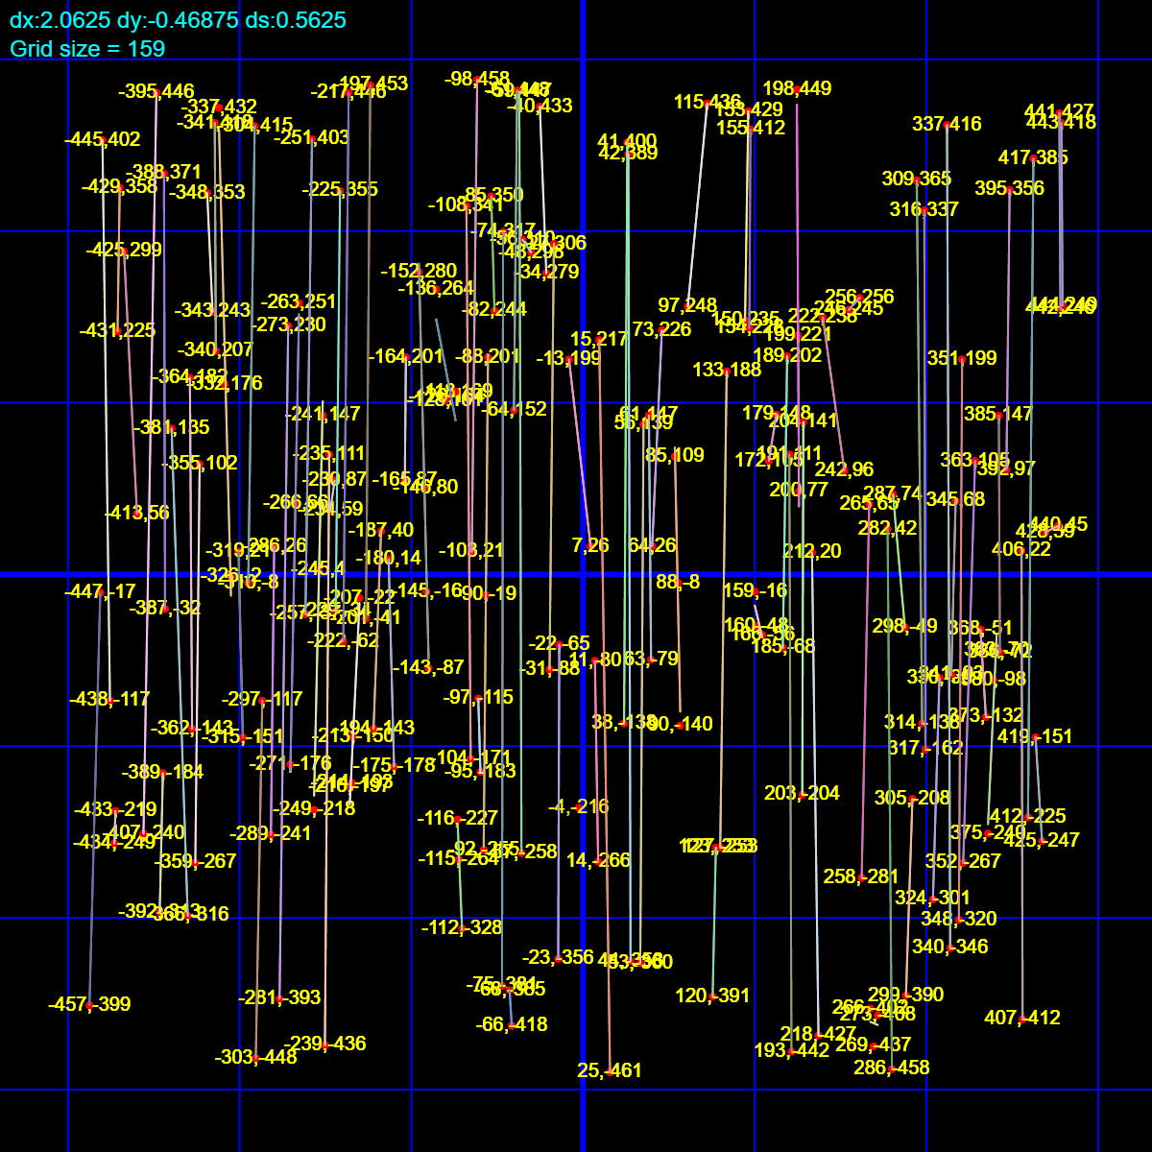

Time taken by the algorithm (in microseconds): 39743

inp9_1.txt (n=200,C=5072)

Recursive algorithm:

Total Cost: 479838

# of lines: 92

-

Time taken by the algorithm (in microseconds): 39561

inp10_0.txt (n=475,C=5038)

Iterative algorithm:

Total Cost: 1.17797e+06

# of lines: 231

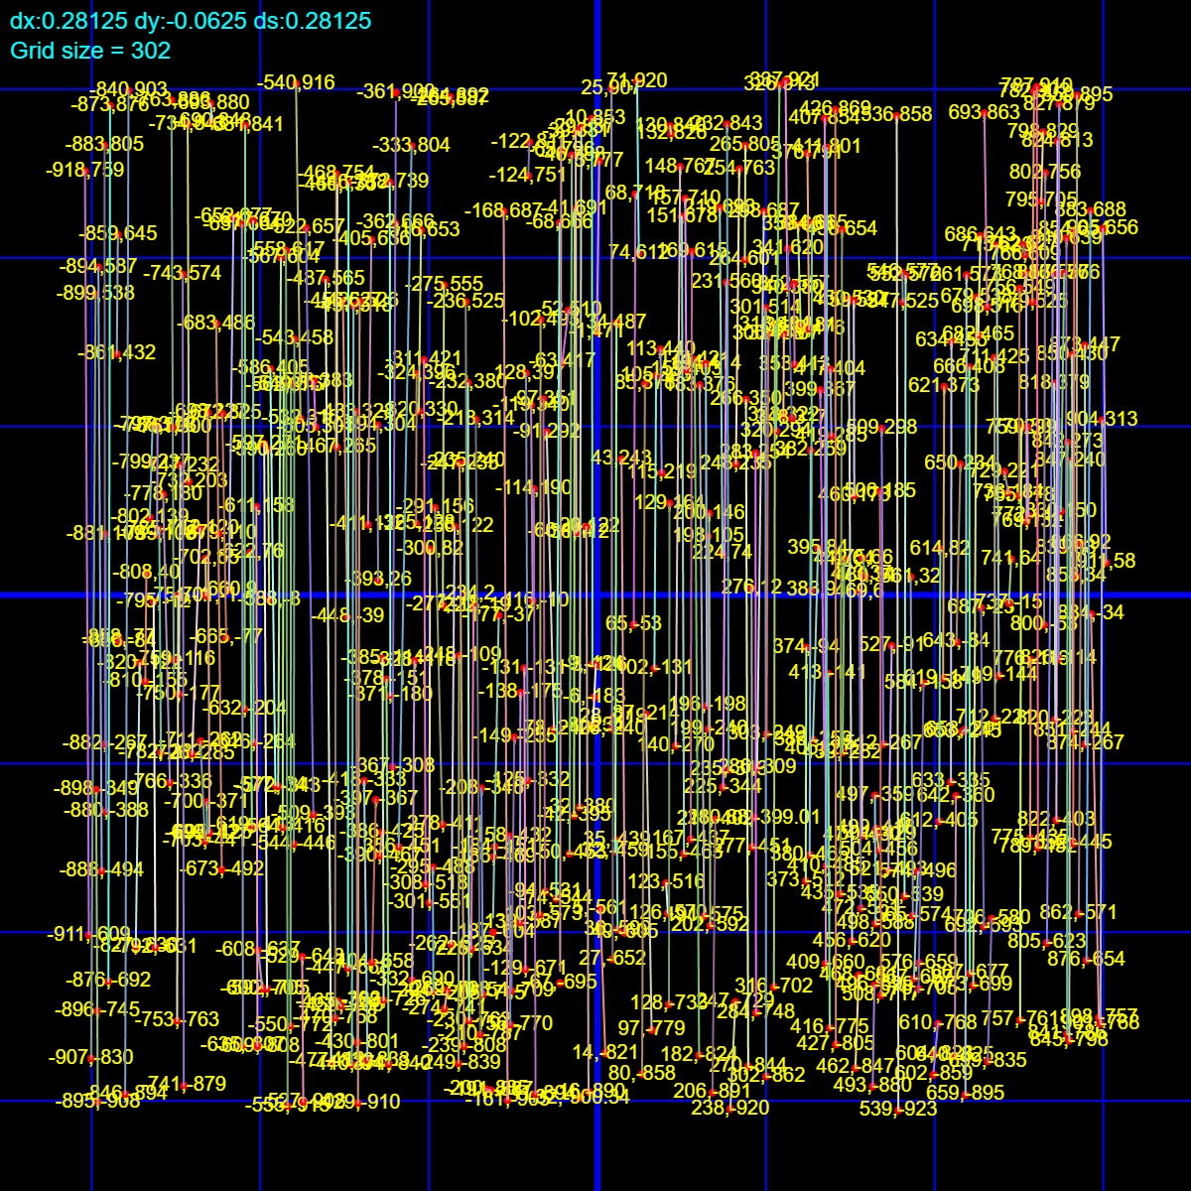

Time taken by the algorithm (in microseconds): 475598

inp10_1.txt (n=475,C=5038)

Recursive algorithm:

Total Cost: 1.17797e+06

# of lines: 231

-

Time taken by the algorithm (in microseconds): 468474

inp11_0.txt (n=300,C=15)

Iterative algorithm:

Total Cost: 2250

# of lines: 150

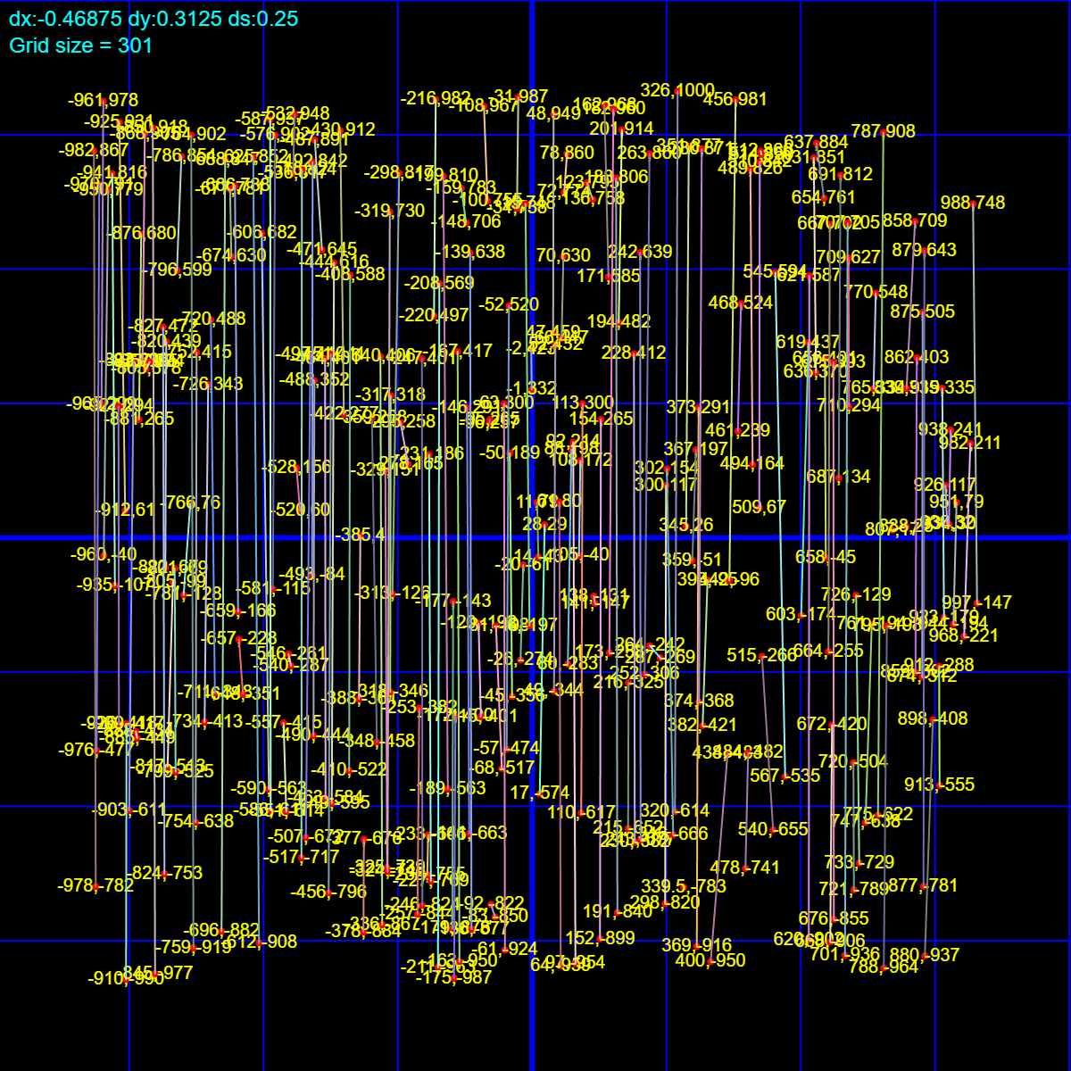

Time taken by the algorithm (in microseconds): 123166

inp11_1.txt (n=300,C=15)

Recursive algorithm:

Total Cost: 2250

# of lines: 150

-

Time taken by the algorithm (in microseconds): 123776

inp12_0.txt (n=376,C=4)

Iterative algorithm:

Total Cost: 751.81

# of lines: 187

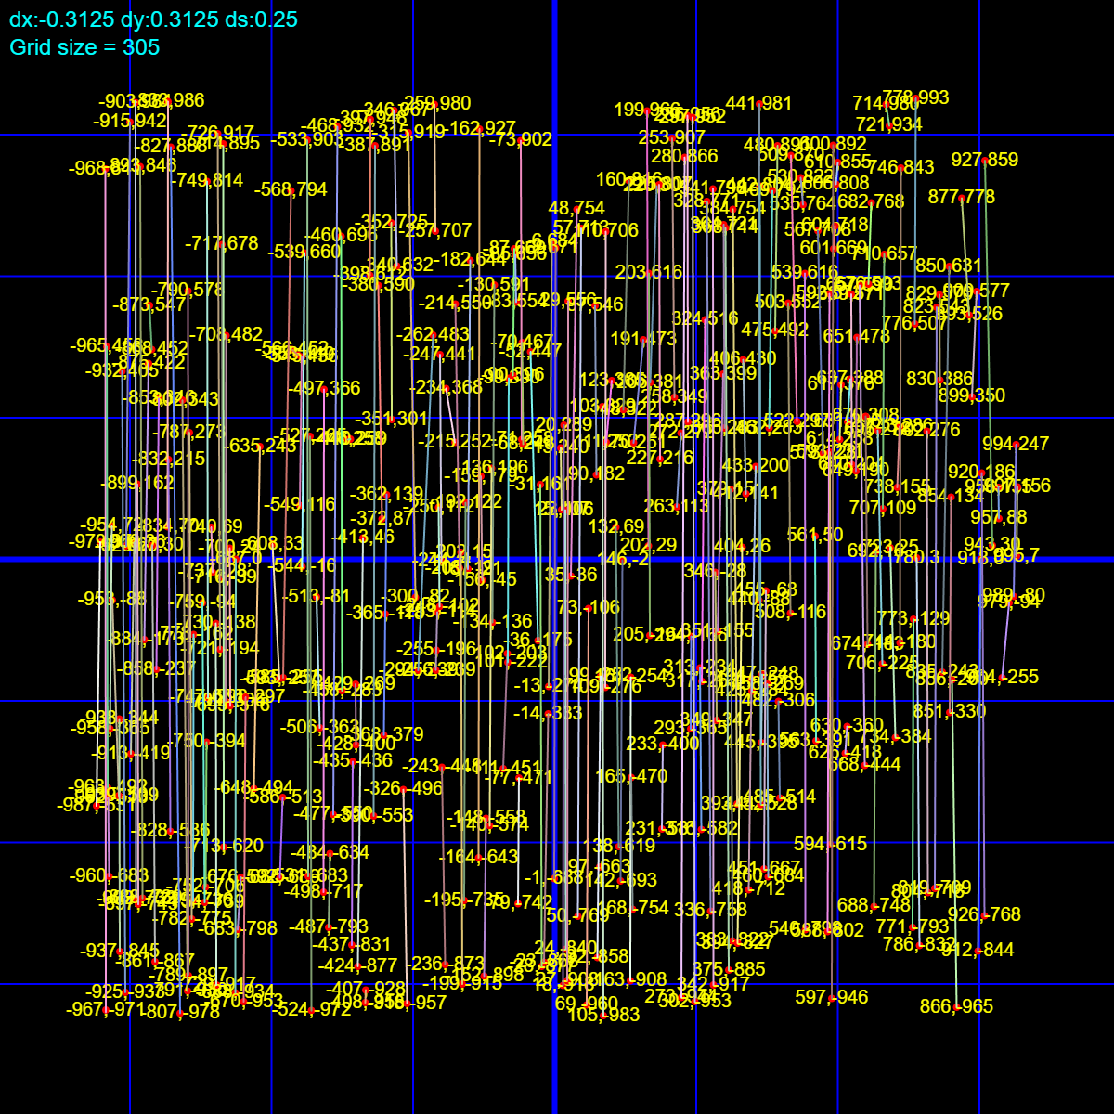

Time taken by the algorithm (in microseconds): 237232

inp12_1.txt (n=376,C=4)

Recursive algorithm:

Total Cost: 751.81

# of lines: 187

-

Time taken by the algorithm (in microseconds): 245051